Python 3.7 and Gurobi 9.5.2 are recommended.

1. Setting the absolute path of instance.



1. Setting the running time in minutes.



3. Modify this line to “**m, n, t, q, demands, distance = self.load_data()**” when running SD instances.

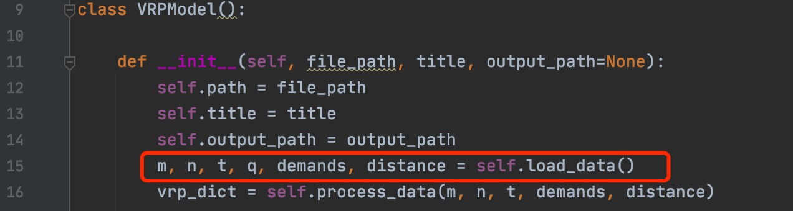

Modify this line to “**m, n, t, q, demands, distance = self._load_data()**” when running P instances.

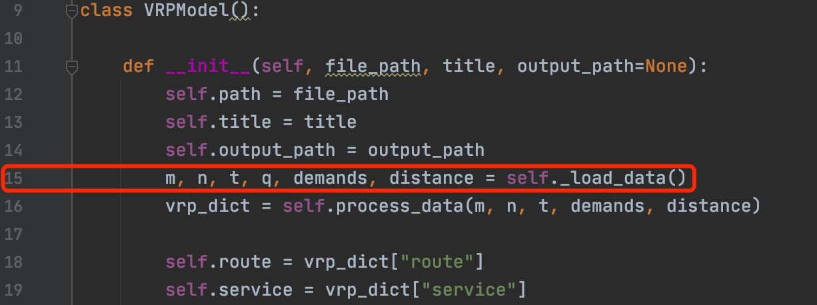

4. Output results are automately saved in the directory as follow, of which the same level with the script. The txt files are allocated into different folders according to the running time and number of depots.

